Goodall’s Talk
Students Name:
Institution Affiliation:

What About Language Makes Us Human and How Does That Make Us Different from Other Species on Earth?
Unlike animals, humans express their thoughts effortlessly through language. The fact that human is naturally linguistic geniuses, defines language as part of humanity. For the non-human organism, the closest they can get to language is through mimic and/or expressing their feeling through sounds accompanied by movement. According to Primatologist, Jane Goodall, primates have the capability relate to language, accompanied by training or their natural experience with the language (Goodall et al., 1999). The Chimp in China, aged 28, has incredible proficiencies like attempting to operate a computer among other complex tasks.
Additionally, Goodall made observations during her long-term research on chimps, showing that they have the ability to modify tools, show affection and experience emotions. Such instances make you wonder what holds back these species from being ‘human’. However, what makes us different from other species, is the ability to speak the language and make sensible opinions for other humans to respond and have a productive conversation (Goodall et al., 1999)... The fascinating specifics about human beings is that we use language to learn or perfect language. Nothing in the world could have such capabilities of shaping the world through language.
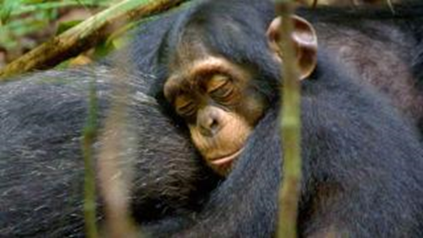
Figure 1: Picture of a chimpanzee showing affection
Why Is Language Essential to The Human Experience?
According to the article written by Sally Augustin Ph.D. in 2010, our languages makes us more likely to conceptualize and interact with what's around us in particular ways. These means that its likely for a language to influence human experiences, where different languages, define or relate to the world differently. The experiences we have are often tied closely to our cultures, thus defining our identity.
Over the history of mankind, we review their past existence artistically. This flow of understanding between languages and their cultures through art, helps us interact vividly to the world today. Surprisingly some experiences have managed to penetrate the 21st century and are well accepted. For example; In Japan, the GO traffic lights have a blue outlook, simply because historically the Japanese used the same word to refer to both blue and green. The contrasting Japanese speech, defining the two colors resulted in the government reviewing the colors since the outside world categorizes them differently.
From the discussions, it is important to appreciate language and its role in our today's experiences. We have seen the essentials that abide language. Most importantly as Jane Goodall, the uniqueness of human beings is that we can speak the language and that should be enough to make it easier for other organisms that depend on our voices.

References
Whiten, A., Goodall, J., McGrew, W. C., Nishida, T., Reynolds, V., Sugiyama, Y. ... & Boesch, C. (1999). Cultures in chimpanzees. Nature, 399(6737), 682.

